TC-AUTH-005
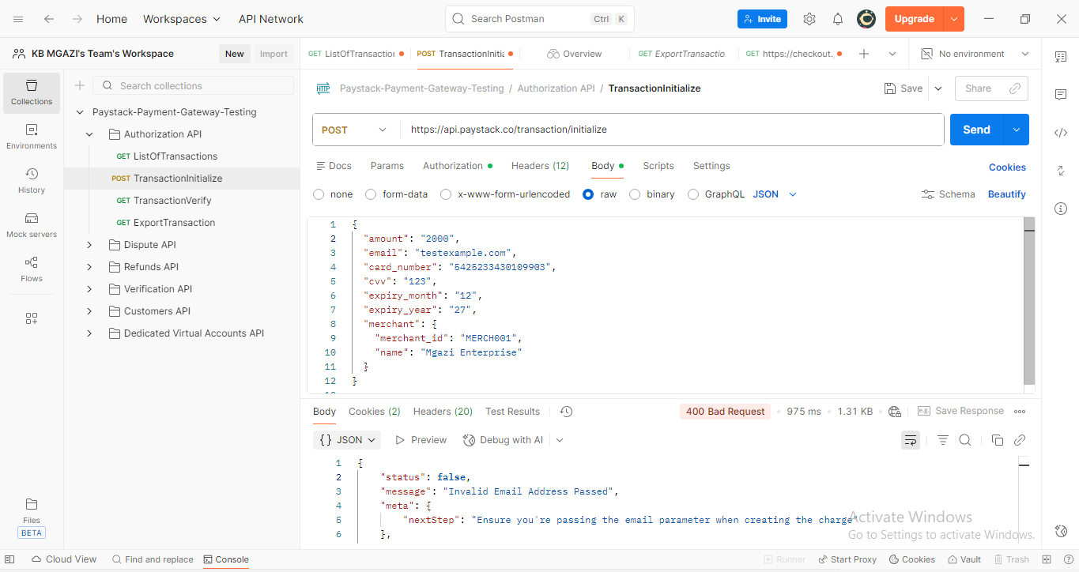
Request:
{
"amount": "2000",
"email": "testexample.com",
"card_number": "5425233430109903",
"cvv": "123",
"expiry_month": "12",
"expiry_year": "27",
"merchant": {
"merchant_id": "MERCH001",
"name": "Mgazi Enterprise"
}
}
Response:
{
"status": false,
"message": "Invalid Email Address Passed",
"meta": {
"nextStep": "Ensure you're passing the email parameter when creating the charge"
},
"type": "validation_error",
"code": "invalid_email_address"
}

